Analog Signal Generation and Reading using dSPACE

1. Prerequisites
1.1. Software Required: dSPACE (ConfigurationDesk, ControlDesk), MATLAB, and Simulink.
1.2. Hardware Required: SCALEXIO LabBox, multimeter, and cables.

2. ConfigurationDesk Setup
2.1. Create a new project in ConfigurationDesk.
2.2. Add the hardware (e.g., SCALEXIO Rack) by importing it in the "Model - function and Hardware resources" section.
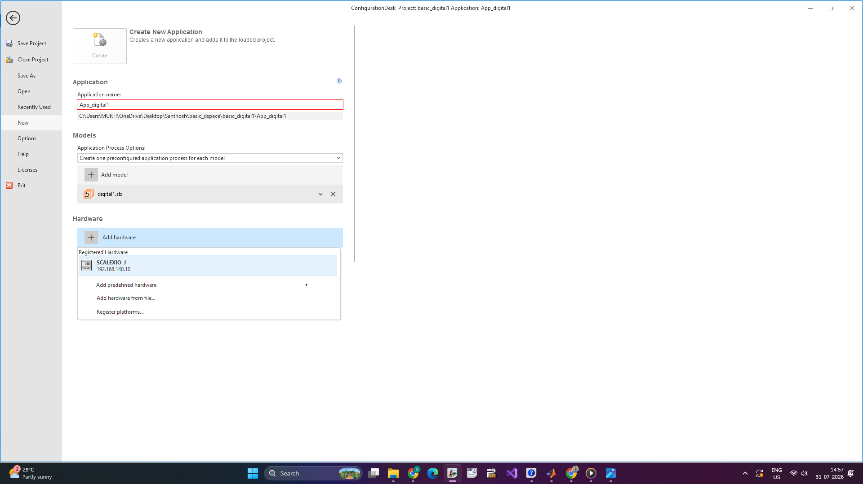
Note: If a Simulink file already exists, it can be loaded. Alternatively, it can be created within the project by selecting "Propagate to Simulink."

3. Analog Signal Generation
3.1. Navigate to the "Signal Chain and Hardware Resources" section and drag the function block for the DS6101 Multi-I/O Board (a 3-slot SCALEXIO I/O board).
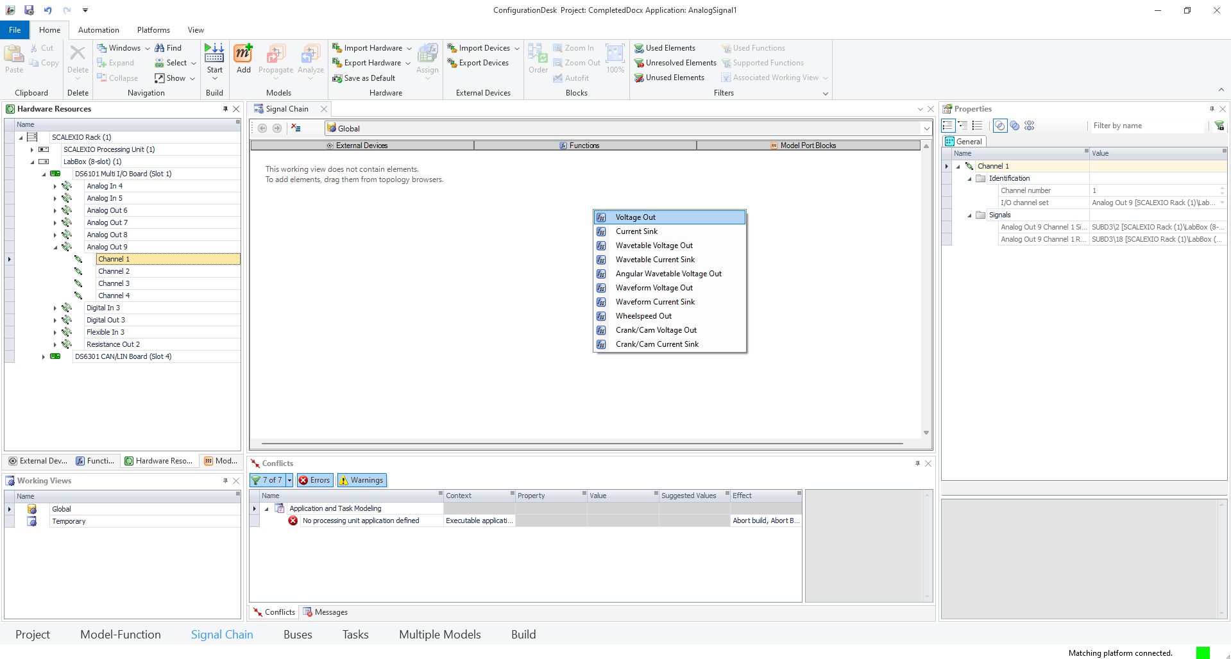
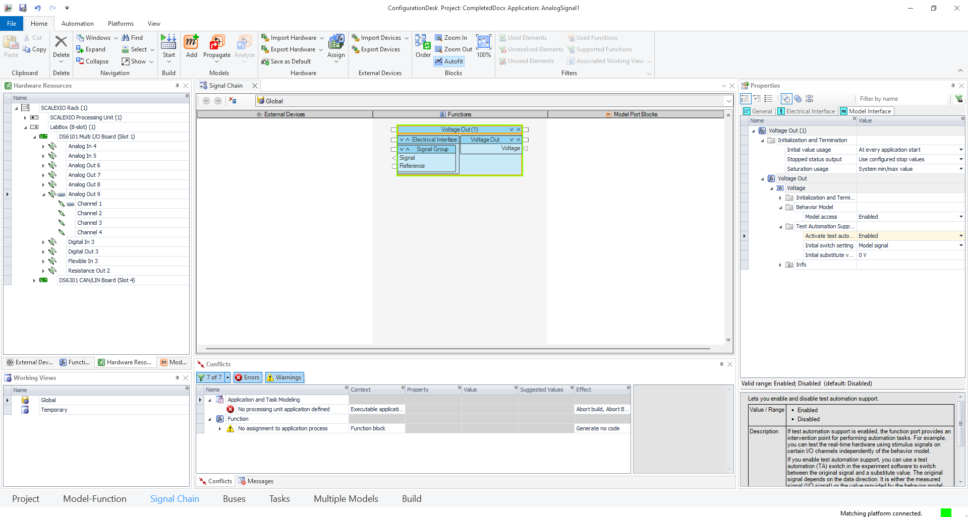
3.2. Select an "Analog Out" channel (e.g., Analog Out 9) based on the required voltage range.
3.3. This channel will generate voltage signals from the ECU or dSPACE system.

4. Analog Signal Reading
4.1. In "Signal Chain and Hardware Resources," drag and drop function blocks for "Analog In" channels (e.g., Analog In 4 or 5).
4.2. These channels facilitate reading voltage inputs from the ECU or dSPACE system.
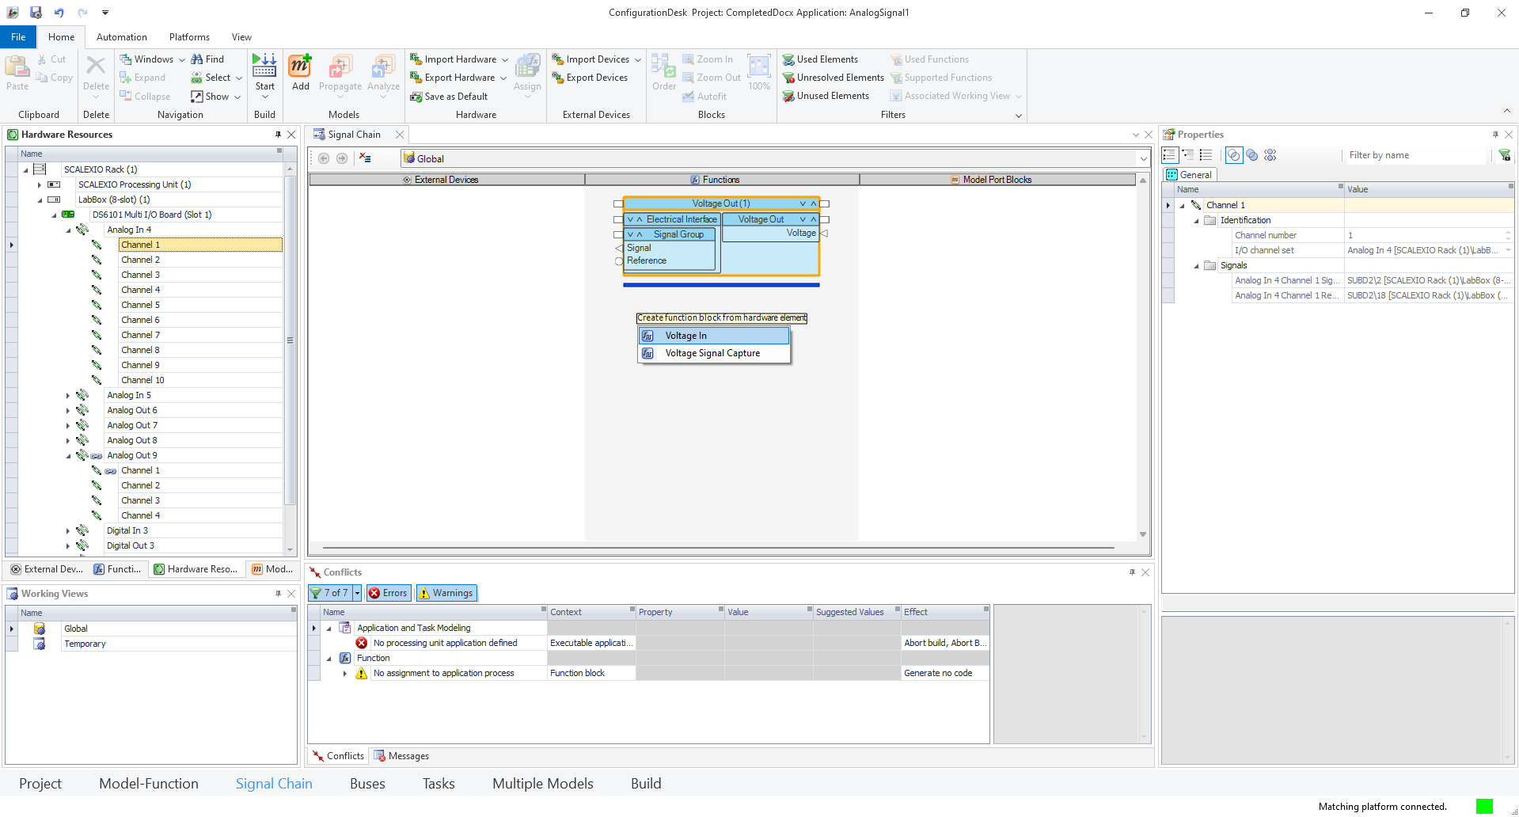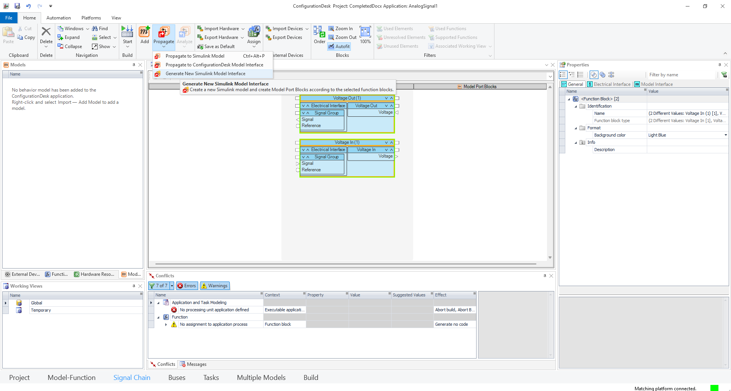

5. Simulink Model Setup
5.1. Enable "Test Automation Support" and "Behavior Model" for the target function blocks.
5.2. Propagate the Simulink model, save it, and import it into the signal chain.
5.3. Connect the model pins, configure the signal chain, and build the project.

Note: The final Simulink model structure should appear as follows:
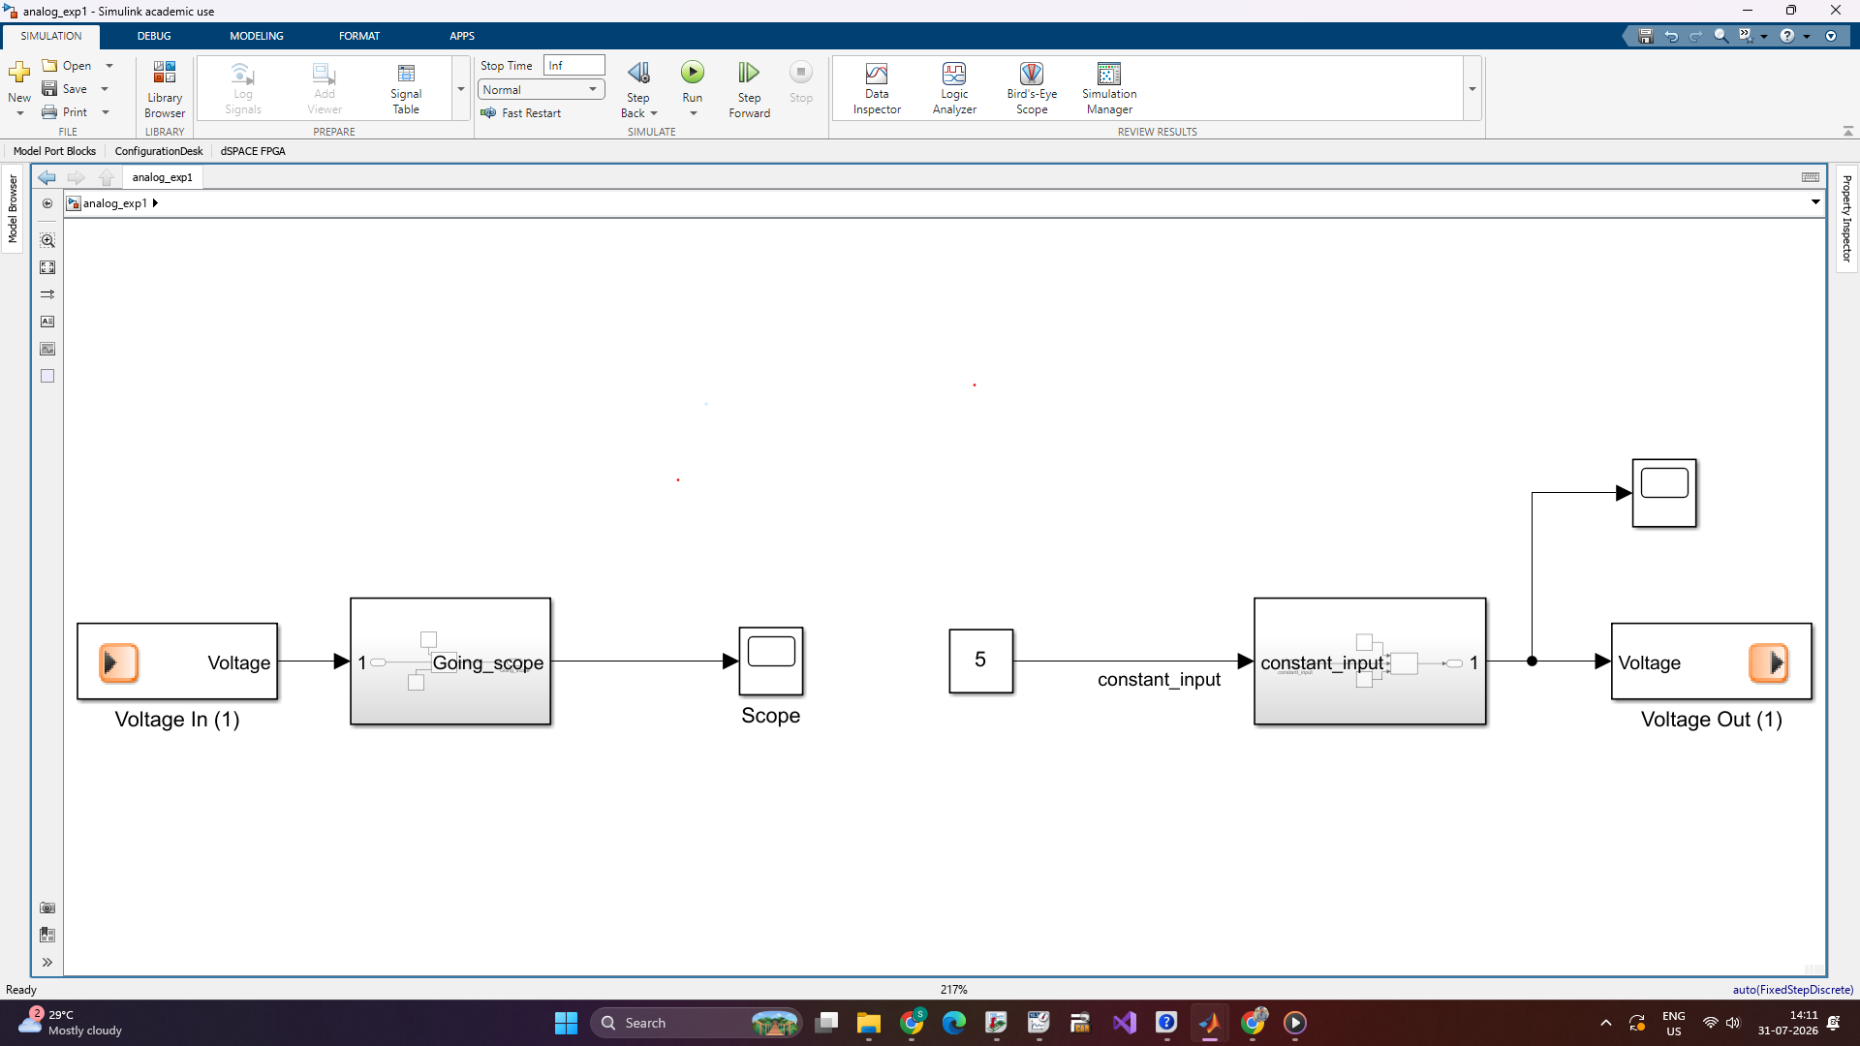
5.4. Once required signals are placed in the signal chain, generate a new Simulink file (or propagate if a file exists).
5.5. Verify pin configurations in ConfigurationDesk for the SCALEXIO LabBox hardware.
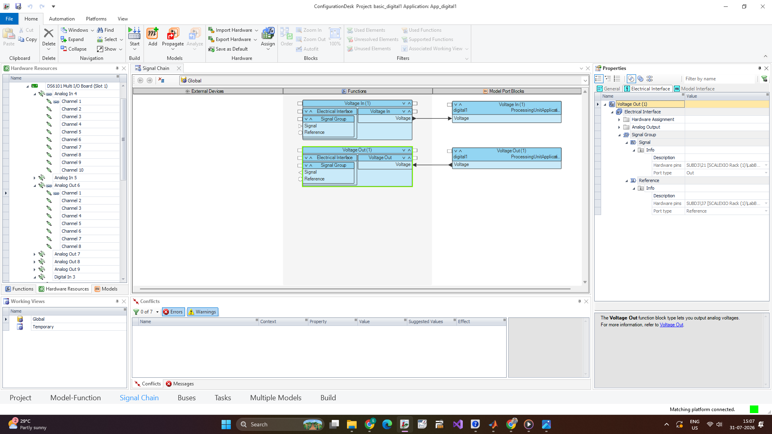

6. ControlDesk Setup
6.1. Create a new project in ControlDesk, selecting the previously created hardware configuration.
6.2. Access model variables and configure the layout for visualization.
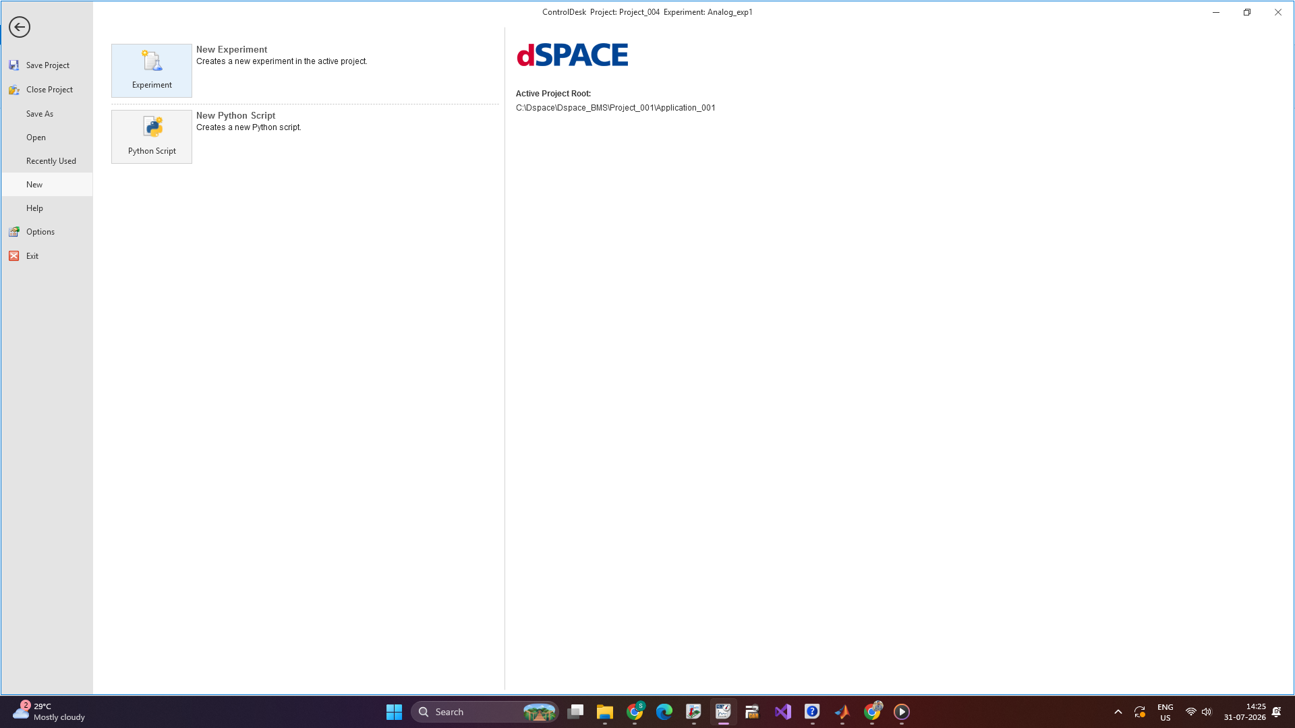
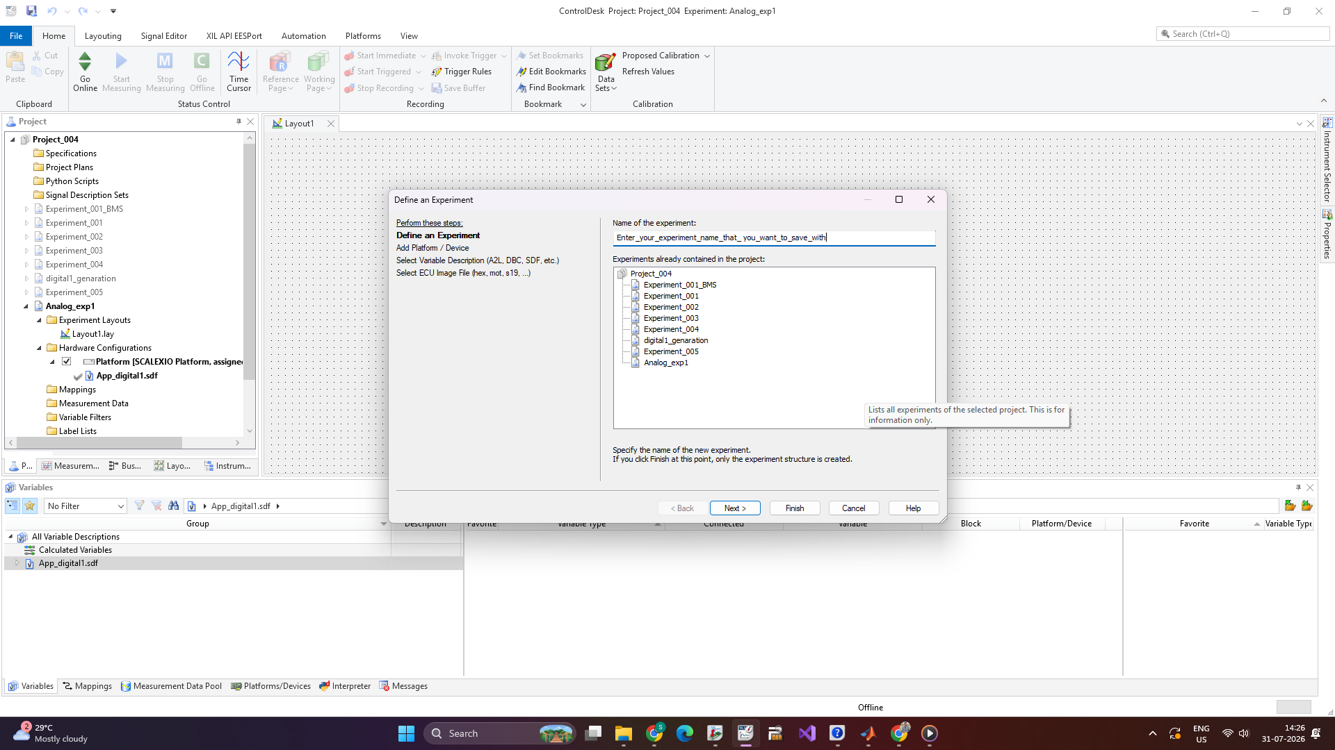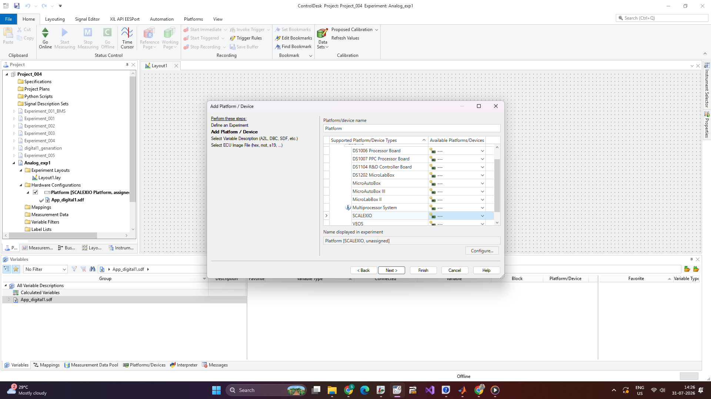
Note: Select the .sdf (Simulink Description File) generated from ConfigurationDesk.
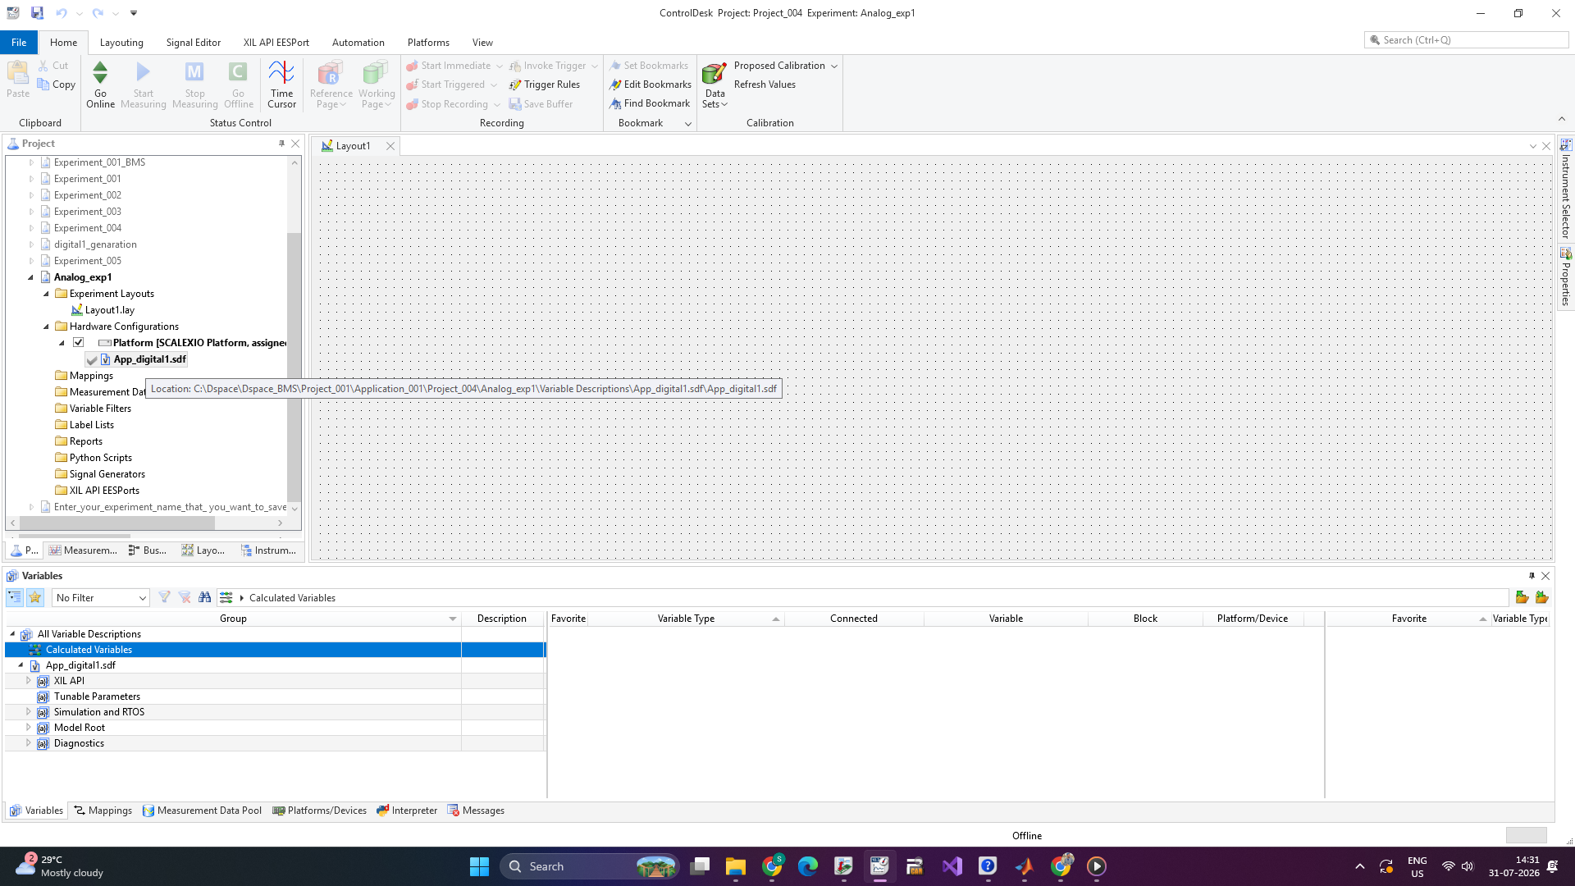
6.3. Access variables via the "Model Root" section; drag and drop the required variables to control or observe.
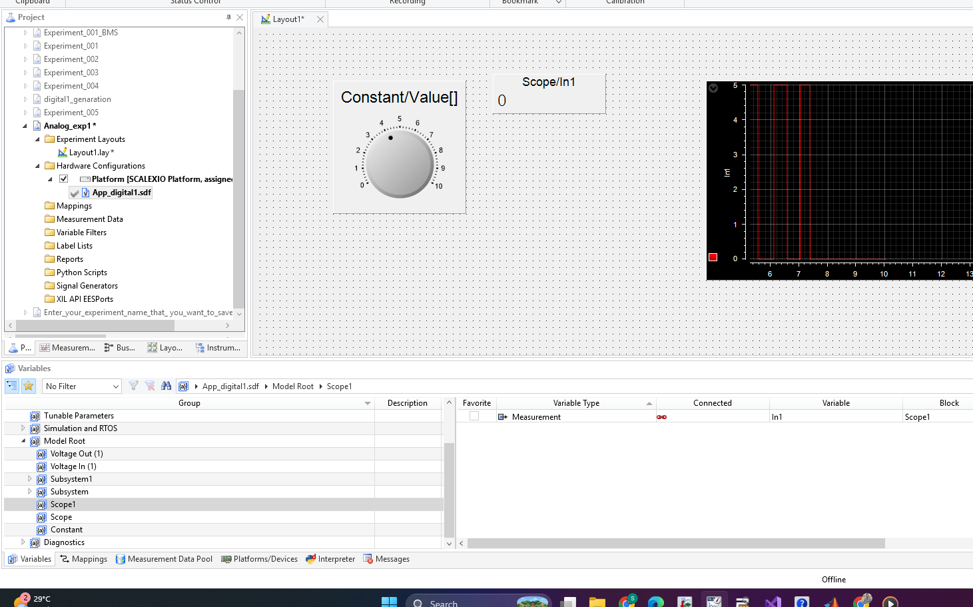
6.4. Ensure the hardware is powered on and connected. Navigate to the "Home" ribbon, select "Go Online," and "Start Measurement" to begin simulation.


7. Hardware Connection
7.1. Establish connections by looping signal and ground wires between specific pins:
- Signal Connection: Connect SUBD3/2 to SUBD2/2 (Verify specific pin configuration for your setup).
- Ground Connection: Connect SUBD3/18 to SUBD2/18.
7.2. Ensure proper grounding for both analog and digital signals.
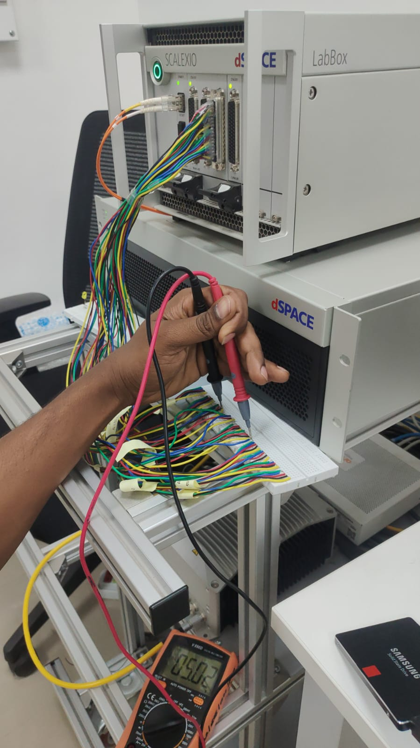

8. Testing and Observation
8.1. Verify signal output from the dSPACE SCALEXIO LabBox. The signals can be monitored in real-time within ControlDesk.

